Blockchain Simulation Project Report



Submitted by:
Atta Ur Rehman BCS223074
Hifza Khan BCS223082
Aleesha Aqeel BCS223093

Submitted to:
Muntaha Tabassum

Table of Content
Table of Content 2
Introduction 4
Project Objectives 4
System Architecture 4
Architecture Diagram 5
Core Components 5
1. Block Structure (block.js) 5
2. Transaction Structure (transaction.js) 6
3. Blockchain Controller (blockchain.js) 6
4. Web Interface (HTML/CSS/JavaScript) 7
Key Features Implementation 7
Block Mining Process 7
1. Code Implementation: 7
Transaction Validation 8
1. Validation Rules: 8
2. Code: 8
Chain Integrity Verification 8
1. Validation Algorithm: 8
2. Code: 8
Tamper Detection System 9
1. Implementation: 9
2. Screenshot: 9
API Endpoints 10
User Interface Components 11
Dashboard 11
Features: 11
Transaction Creation Panel 12
Quick Actions 12
Blockchain Blocks Display 12
Working Flow 13
Normal Operation Flow 13
Tamper Detection Flow 13
Validation Flow 13
Technical Implementation Details 13
Cryptographic Functions 14
Merkle Tree Implementation 14
Frontend-Backend Communication 15
Limitations 15
Future Improvement 15
Conclusion 15
Appendices 16
Appendix A: Installation Instructions 16
Appendix B: File Structure 16
Appendix C: Team Contributions 17
Appendix D: Interface 18

Introduction
This project focuses on developing a blockchain simulation to practically demonstrate how blockchain mechanisms operate behind the scenes. Instead of relying on theoretical descriptions, the system has been designed to show how blocks, transactions, and hashes interact within a controlled software environment. The blockchain is implemented using JavaScript (Node.js for backend, HTML/CSS/JavaScript for frontend), where each operation such as block creation, transaction verification, and mining is executed programmatically and can be observed through a web interface.
The motivation behind this project is to bridge the gap between conceptual understanding and actual implementation. By simulating a blockchain rather than building a full cryptocurrency network, the project allows users to clearly see how data is stored, linked, and protected from unauthorized modification. The inclusion of transaction handling, block mining, and validation mechanisms makes it easier to understand why blockchain systems are considered secure and reliable.

Project Objectives
The primary objective of this project is to build a working blockchain model that reflects the essential behavior of real blockchain systems while remaining simple and understandable. The project aims to:
- Demonstrate how transactions are created and checked for validity before being stored
- Show how multiple transactions are grouped into blocks
- Illustrate how blocks are permanently connected using cryptographic hashes
- Show how mining rewards are generated
- Demonstrate blockchain integrity verification after every operation
- Highlight the impact of data manipulation through tamper detection
Additionally, the project seeks to highlight the impact of data manipulation within a blockchain. By intentionally modifying stored data and validating the chain afterward, the system clearly shows how even a minor change can disrupt the entire blockchain structure. This helps emphasize the importance of immutability and trust in blockchain-based systems.

System Architecture
The system is structured using a client–server model where blockchain operations are handled on the server side (Node.js + Express), while user interaction takes place through a browser-based interface (HTML/CSS/JavaScript).

Architecture Diagram
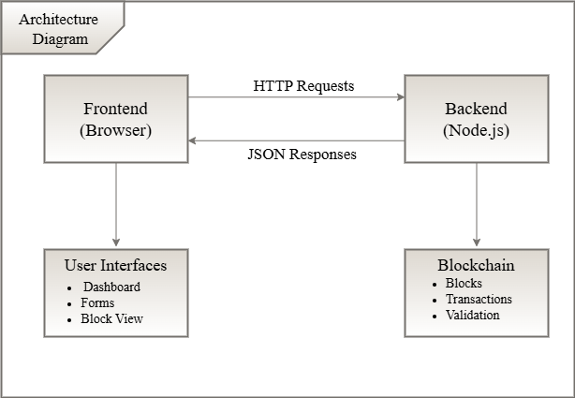
Figure 0.1: Architecture Diagram for Blockchain Simulation

Core Components
At the core of the system are four interconnected components:

Block Structure (block.js)
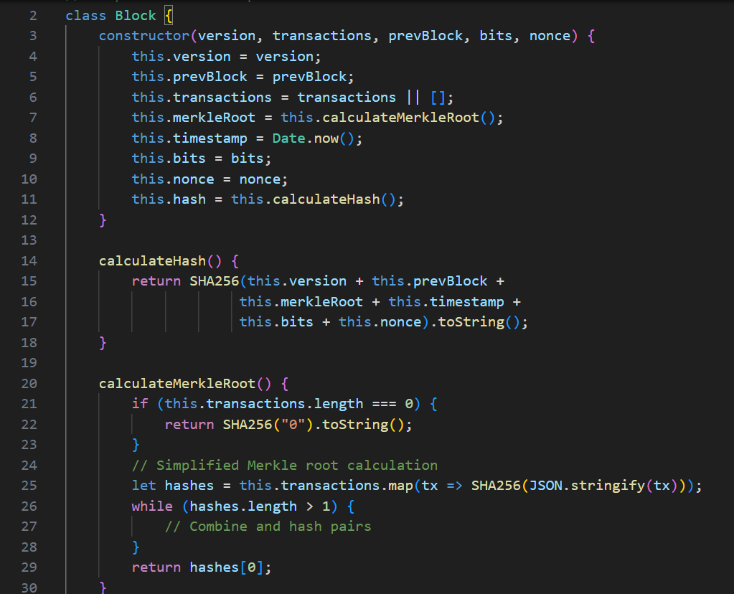
Figure 0.2: Block Structure code

Transaction Structure (transaction.js)
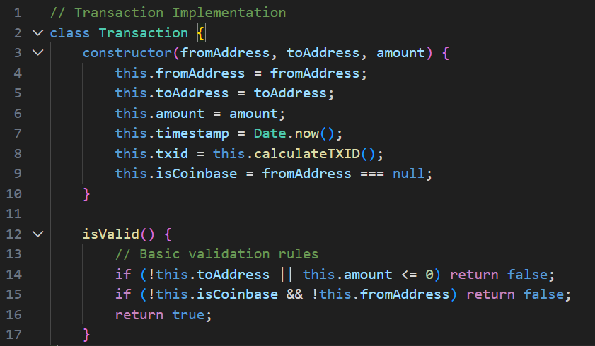
Figure 0.3: Transaction Structure code

Blockchain Controller (blockchain.js)
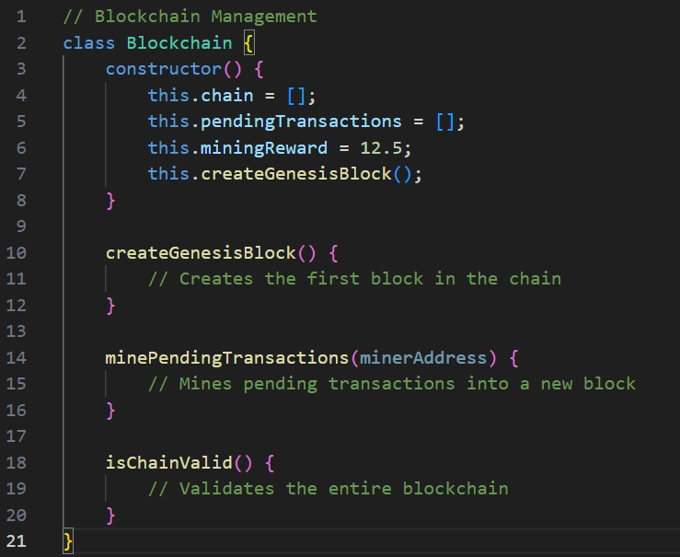
Figure 0.4: Blockchain Controller code

Web Interface (HTML/CSS/JavaScript)
- Dashboard: Shows real-time statistics (blocks count, pending transactions, chain status, miner balance)
- Transaction Panel: Allows creating new transactions
- Blocks View: Displays all blocks in the blockchain with details
- Quick Actions: Buttons for rapid testing (Add 3/5 transactions)
- Control Panel: Mining, validation, and tamper test buttons

Key Features Implementation

Block Mining Process

Code Implementation:
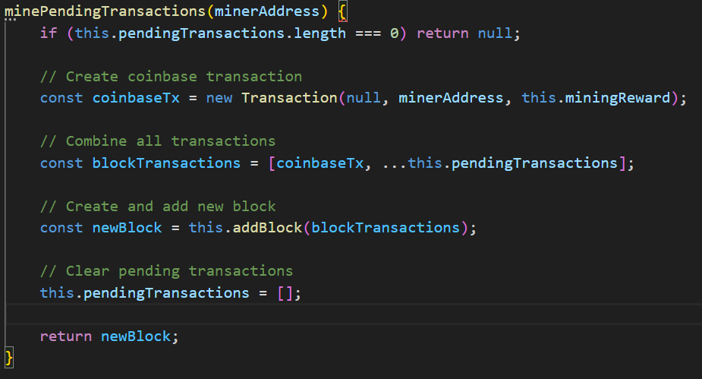
Figure 5: Code Implementation of Block Mining Process
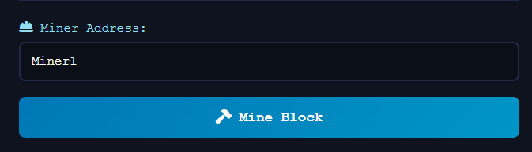
Figure 6: Miner Section
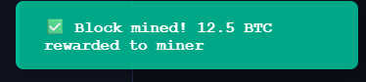
Figure 7: Successful Message

Transaction Validation

Validation Rules:
- Receiver address must be present
- Amount must be positive
- Sender address required for non-coinbase transactions
- Transaction ID must be valid

Code:
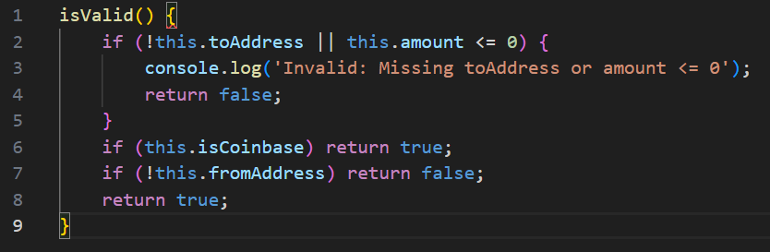
Figure 8: Transaction Validation

Chain Integrity Verification

Validation Algorithm:
For each block in chain:
1. Recalculate block hash
2. Compare with stored hash
3. Verify previous hash matches previous block's hash
4. Check all transactions are valid

Code:
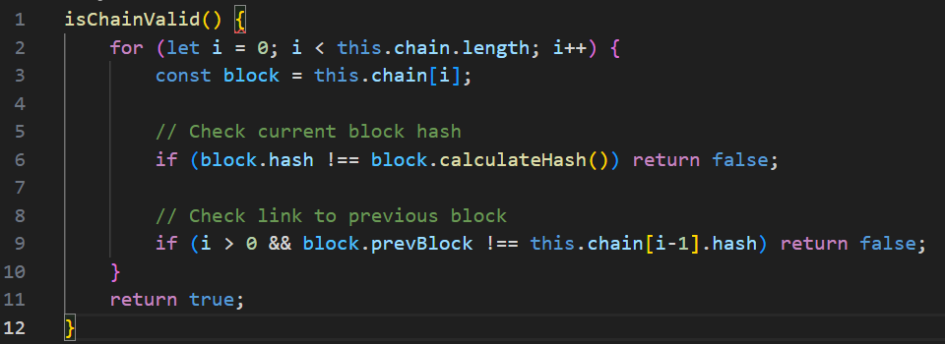
Figure 9: Chain Integrity Verification

Tamper Detection System

Implementation:
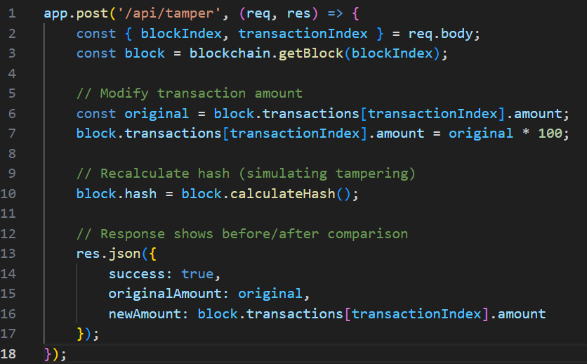
Figure 10: Temper Detection Code

Screenshot:

Figure 11: Temper Test Button
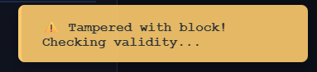
Figure 12: Temper successful message
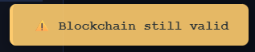
Figure 13: Blockchain Validity Message

API Endpoints
Table 1: API Endpoint
Method | Endpoint | Description | Request Body | Response
GET | /api/blockchain | Get blockchain info | None | {blocks, pendingTransactions, isValid}
GET | /api/pending-transactions | Get pending transactions | None | {pendingTransactions, count}
POST | /api/transaction | Create new transaction | {from, to, amount} | {success, message, transaction}
POST | /api/mine | Mine pending transactions | {minerAddress} | {success, message, block, reward}
GET | /api/validate | Validate blockchain | None | {valid, message}
POST | /api/tamper | Tamper with block (demo) | {blockIndex, transactionIndex} | {success, originalAmount, newAmount}
GET | /api/balance/:address | Check address balance | None | {address, balance}

User Interface Components

Dashboard
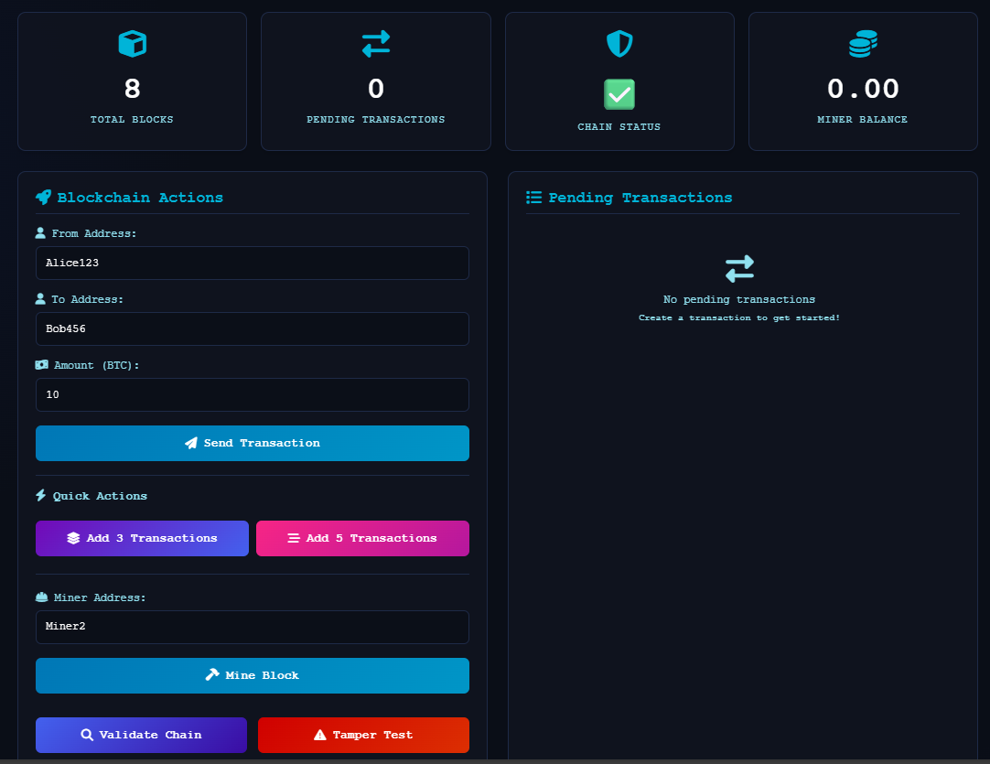
Figure 14: Dashboard

Features:
- Total Blocks: Shows current blockchain length
- Pending Transactions: Count of unconfirmed transactions
- Chain Status: Green checkmark (valid) or red X (invalid)
- Miner Balance: Current balance of miner address

Transaction Creation Panel
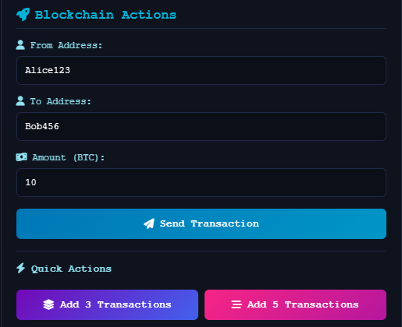
Figure 15: Transaction Creation Panel

Quick Actions
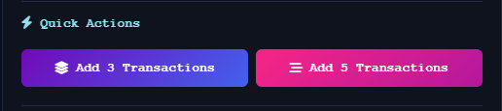
Figure 16: Quick Action
- Add 3 Transactions: Automatically creates 3 random transactions
- Add 5 Transactions: Automatically creates 5 random transactions

Blockchain Blocks Display
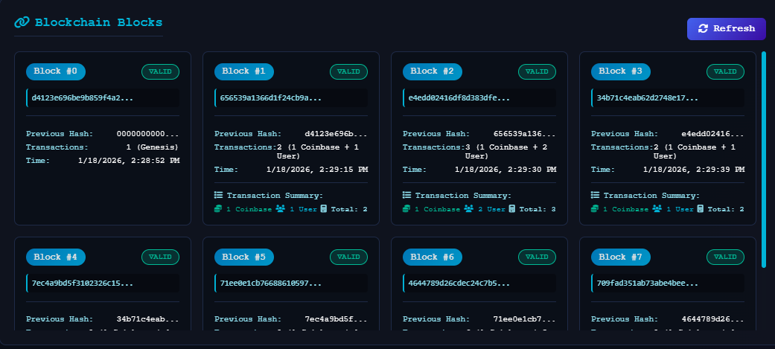
Figure 17: Blockchain Blocks Display
Each Block Shows:
- Block number
- Status (VALID/INVALID)
- Hash (truncated)
- Previous hash
- Transaction count with breakdown
- Timestamp

Working Flow

Normal Operation Flow
1. User creates transaction, Added to pending pool
2. Multiple transactions accumulate, Shown in pending list
3. User clicks "Mine Block", Transactions moved to new block
4. Block added to chain, Pending transactions cleared
5. Chain validated, Status updated
6. Miner receives reward, Balance updated

Tamper Detection Flow
1. User creates and mines several transactions
2. User clicks "Tamper Test", Modifies transaction in block 1
3. System recalculates modified block's hash
4. User clicks "Validate Chain", Chain shows as invalid
5. System detects hash mismatch, Demonstrates immutability

Validation Flow
1. System iterates through all blocks
2. For each block:
a. Recalculate hash from block data
b. Compare with stored hash
c. Verify previous hash link
3. If any mismatch found, Chain marked invalid
4. UI updates chain status indicator

Technical Implementation Details

Cryptographic Functions
const SHA256 = require('crypto-js/sha256');
Used for:
1. Block hash calculation
2. Transaction ID generation
3. Merkle root calculation
4. Integrity verification

Merkle Tree Implementation
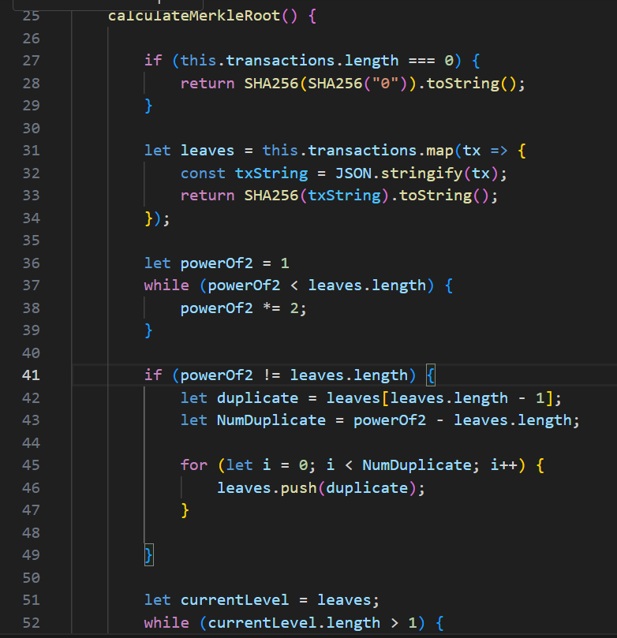
Figure 18: Merkle Tree Implementation

Frontend-Backend Communication
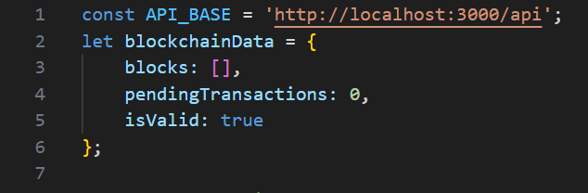
Figure 19: Front-end and backend communication code

Limitations
Since this is a learning project and not a real blockchain system, there are several things we didn't include. Our blockchain runs on just one computer server instead of many computers spread around the world. The mining difficulty stays the same all the time and doesn't get harder as more blocks are added. We don't use real digital signatures or passwords - addresses are just simple text names like "Alice123" instead of secure cryptographic keys. There's no network connecting different computers together, so it's not a true peer-to-peer system. We don't have actual wallets with private keys, just simple address strings. Finally, there's no competitive mining where multiple people race to solve puzzles - mining happens instantly when you click the button.

Future Improvement
There are many ways this project could be improved if we wanted to make it more like a real blockchain. We could add proper digital signatures using public and private keys so only the real owner can spend their money. We could change how transactions are tracked using the UTXO model (like Bitcoin does) instead of simple account balances. We could connect multiple computers together to create a real decentralized network. The mining difficulty could automatically adjust based on how fast blocks are being created. We could add a proper wallet system that generates secure key pairs. We could even add smart contracts that automatically execute when conditions are met, like simple programmable money rules.

Conclusion
This project successfully shows how a blockchain works through actual hands-on experience. By letting users create transactions, mine blocks, check for tampering, and validate the chain, it makes complex blockchain ideas easy to understand. The system clearly demonstrates how blocks are linked together and why changing old transactions is nearly impossible to hide.

The interactive website makes everything visible - you can watch transactions happen in real time, see blocks being added, test what happens when someone tries to cheat, and track all the statistics. Even though it's simplified for learning purposes, it successfully turns abstract blockchain concepts into something you can actually see and use. This project provides a solid starting point for anyone wanting to understand blockchain technology better and could be expanded into more advanced applications in the future.

Appendices

Appendix A: Installation Instructions
1. Install Node.js
2. Install dependencies
npm install express crypto-js

3. Run the server
node server.js

4. Open browser
http://localhost:3000

Appendix B: File Structure
blockchain-simulation/
├── server.js # Main server file
├── blockchain.js # Blockchain logic
├── block.js # Block structure
├── transaction.js # Transaction structure
├── package.json # Dependencies
├── package-lock.json
└── public/
├── index.html # Main interface
├── style.css # Styling
└── script.js # Frontend logic

Appendix C: Team Contributions
Hifza Khan (BCS223082): Blockchain logic, backend API
Atta Ur Rehman (BCS223074): Frontend interface, UI design
Aleesha Aqeel (BCS223093): Testing, documentation, report

Appendix D: Interface
